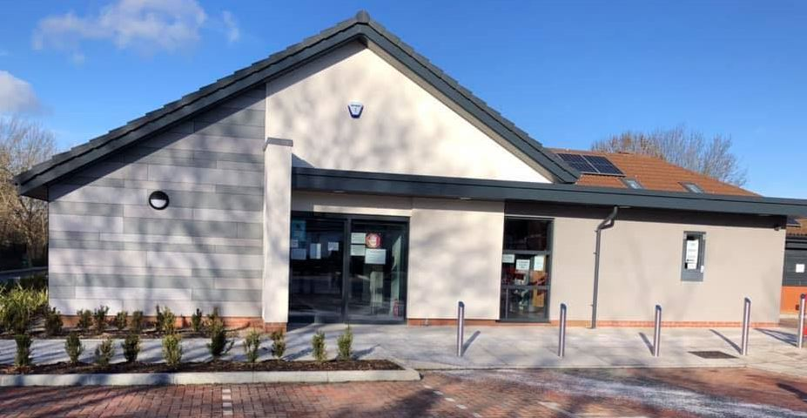
PATIENTHTHE BURBAGE SURGERY PATIENT NEWSLETTER

Welcome to the Autumn/Winter Edition of your Patients’ Newsletter. We hope you enjoy reading through and finding out what’s happening within your practice.

Issue: Autumn/Winter 2023

ONLINE CONSULTATIONS


From the 1st November 2023 the practice has introduced the Online Consultation facility for patients to make requests to the practice. These requests are for NON URGENT Medical requests and advice, admin queries, test results, referral queries etc. This service is available Monday – Friday between 7.00am – 11.00am. It can be accessed via the practice website.
Your request will be handled in exactly the same way whether this is done online or via a phonecall to ensure that this is equal for all patients. However, please be aware completing the request online will provide you with more discretion should you not wish to discuss your medical problem with our team.
Your request will then be reviewed by our team who will be able to arrange the appropriate follow up, including face to face appointments, telephone appointments and onward referrals. For Non Urgent Medical Requests there is a 3 working day turn around and for Admin request there is a 5 working day turn around.
We are continually reviewing this system and making improvements to ensure that this is working for all patients, we thank you all for your patience.

IMPORTANT NOTICE REGARDING WOLVEY SURGERY

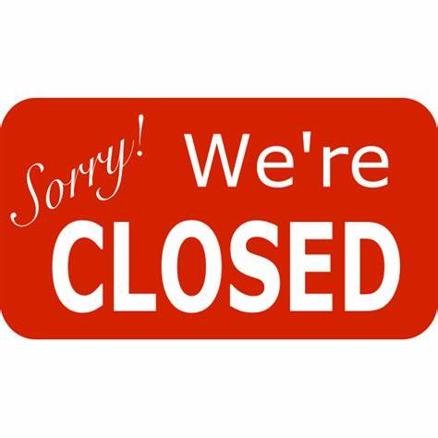
Due to scheduled refurbishment work being carried out, Wolvey Surgery and Dispensary will be closed from Thursday 7th December to Friday 15th December 2023. The surgery and Dispensary will reopen on Monday 18th December 2023. Please accept our apologies for any inconvenience caused during this time. All prescriptions will be available to collect from The Burbage Surgery. If you need to order your medication early to be able to pick up from Wolvey before Thursday 7th December – please contact our dispensary team so that we can arrange this if possible.
Thank you for your patience and understanding.

The Burbage Surgery Website

We are continually making improvements to our website to ensure it is the most user friendly it can be.
he Burbage Surgery Website
Christmas Opening Times

Monday 18th December – Open as Usual
Tuesday 19th December - Open as Usual
Wednesday 20th December - Open as Usual
Thursday 21st December - Open as Usual
Friday 22nd December - Open as Usual
Saturday 23rd December – CLOSED
Sunday 24th December – CLOSED
Monday 25th December – CLOSED
Tuesday 26th December – CLOSED
Wednseday 27th December – Open as Usual
Thursday 28th December – Open as Usual
Friday 29th December - Open as Usual
Saturday 30th December – CLOSED
Sunday 31st December – CLOSED
Monday 1st January – CLOSED
Reopen Tuesday 2nd January – Open as Usual

Learning Disability Healthchecks


Are you over 14 years old and have a Learning Disability?
A health check every year can help you stay well by talking to a nurse about your health and finding any problems early. Lots of different checks will be done like your height, your weight and your blood pressure. We will send you an invite to ask if you would like to come in you for this check, so please look out for this.

Winter Campaigns


It is not too late to book your Flu vaccination here at the surgery. All eligible patients are being invited to book their appointments with our Practice Nurses Donna or Kinjal, or our HCA Kirsty. The Flu campaign runs until the end of March 24 so plenty of time to get your Flu vaccination done.

SHINGLES AND PNEUMOCOCCAL VACCINATIONS – These are also being offered to eligible patients and invites will be sent out. The shingles campaign has now been extended to new age groups. Our Nursing team will update you on which vaccine is appropriate for you.

COVID VACCINATIONS are being carried out at centres around Leicestershire. Please contact 119 or visit COVID-19 vaccination services - NHS (ww.nhs.uk)

NHS App
If you require online access to your medical records then please download the NHS app
It doesn’t replace existing services though, and you can still contact us in the usual ways.
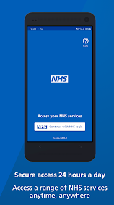
Once you have verified your identity in the app, you will have easy, 24/7 access to a growing range of health services and information. You can:
- order repeat prescriptions
- access NHS 111 online
- find NHS services
- view your health records
- Submit non urgent medical requests
- & much more…

GP WORKING DAYS

Please see below the GP working days.

 | MON | TUE | WED | THU | FRI
Dr W Turner (M) | √ |  | √ |  | √
Dr R Turner (F) | √ | √ | √
Dr P Thomason (M) | √ | √ | √ |  | √
Dr V Bolarum (M) | √ | √ |  | √ | √
Dr Y McManus (F) |  |  | √ | √ | √
Dr R Walker (F) | √ |  | √ | √
Dr M Bhanot (F) |  | √ |  | √ | √

Current Registrars –

Dr R Upreti (M)
Dr G Zaidi (M)
Dr B Hunjan (M)
Dr T Mekala (F)

ADVANCED NURSE PRACTITIONER AND PARAMEDIC APPOINTMENTS


Our Advanced Nurse Practitioner Mariska joined the practice in August 2023 and our Paramedic Kelvin joined in July 2023. Both work alongside the GP’s to support them on a daily basis seeing acute, on the day problems. You can book in to see Mariska or Kelvin for any minor illness ailments including chest infections, UTI’s, ear infections etc.

 | MON | TUES | WEDS | THURS | FRI
Mariska | √ | √ | √ | √
Kelvin |  | √ | √ |  | √

PATIENT PARTICIPATION GROUP (PPG)


The Burbage Surgery Patient Participation Group have been nominated for an award in the annual Hinckley and Bosworth Council – Making a Difference Award 2023. These awards recognise and celebrate the contribution that volunteers make in supporting our community and improving quality of life for our patients. We have been nominated for the category of “Creating a sense of community group”. All nominees will receive an award presented by the Mayor for Hinckley and Bosworth. The awards ceremony is taking place on Thursday 30th November.



PPG COFFEE MORNING


The Burbage Patient Participation Group hold a monthly Coffee Morning every month for patients to pop along, have a coffee/tea, a chat and listen to Guest Speakers. Everyone is welcome so please pop along.

WHEN – 1st Friday of every month
TIME – 10.00AM – 12.00PM
VENUE – The Burbage Pentecostal Church, Tilton Road, Burbage.

CLOSED FOR TRAINING DATES

The Practice will be closed on the 3rd Thursday afternoon of the month for staff training. This is a Countywide closure and the staff attend regular training on these specific dates. Please see below our closed dates for the next 5 months:
16th November 2023
NO CLOSURE IN DECEMBER
18th January 2024
15th February 2024
21st March 2024

DO WE HAVE YOUR UP-TO-DATE DETAILS????


It is important that we have the correct up to date details for you. If they are not up to date you may miss out on important healthcare updates and invitations regarding appointments, results or referrals. We can also provide you with a text message reminder for any pre-booked appointments. You can update your details at reception, give us a call on 01455 634879 after 11.00am or, if you are registered, via the NHS App. You can also email the practice – the burbage.surgery@nhs.net.

